Software Requirements Specification

Version 0.1

May 23, 2015

MyFTP

Kamil Rodzik

Table of Contents

Table of Contents i
1.0. Introduction 1
1.1. Purpose 1
1.2. Scope of Project 1
1.3. Glossary 2
1.4. References 2
2.0. Overall Description 3
2.1 System Environment 3
2.2 Operating Environment 4
2.3 Design and Implementation Constraints 4
2.4 Functional Requirements Specification 4
2.4.1 User Use Cases 4
Use case: Connect 5
Use case: Upload File 5
Use case: Download File 5
Use case: Download List of Files 6
Use case: Delete File 6
Use case: Rename File 6
Use case: Disconnect 7
Use case: Show Help 7
2.5 User Characteristics 7
3.0. Requirements Specification 8
3.1 External Interface Requirements 8
3.2 Functional Requirements 8
3.2.1 Connect 8
3.2.2 Upload File 9
3.2.3 Download File 10
3.2.4 Download List of Files 10
3.2.5 Delete File 11
3.2.6 Rename File 12
3.2.7 Disconnect 12
3.2.8 Show Help 13
3.3 Non-Functional Requirements 13
3.3.1 Performance 13

1.0. Introduction

1.1. Purpose
The purpose of this document is to present a detailed description of the MyFTP system, which is my version of the FTP (File Transfer Protocol). It will explain the purpose and features of the system, what the system will do and the constraints under which it must operate.

1.2. Scope of Project
This software system will provide similar possibilities to original FTP (File Transfer Protocol). MyFTP will enable multiple client connections to server. It will use TCP/IP protocol to transfer files between server and clients. Server application will store files in directory which will be specified in configuration file. Both client, and server will have configuration file which will describe their configuration e.g. directory root path for server. Server will free client resources when he disconnect. Client application will connect to server and allows to download list of files, any existing file, upload files to server, delete files and rename a file.
In more general, MyFTP will enable to transfer files from one client to another using server and enable storing client files, and perform operations on them.

1.3. Glossary
Term | Definition
Client | Software that accesses a service made available by a server.
Server | Software that provides resource or service. Used for serves computer files.
TCP/IP | Protocol which provides reliable, ordered and error-checked delivery of a stream of octets between applications running on hosts communicating over an IP network.
List of stored files | Text list contains name of all files stored in server directory.
Download | Receive data from client/server.
Upload | Sending data to another client/server.
Configuration file | Textual file used to store application configurations.

1.4. References
GitHub repository: https://github.com/madcap112/MyFTP
Rules of file name nomenclature: http://vlaurie.com/computers2/Articles/filenames.htm
Google Style Guide: https://google-styleguide.googlecode.com/svn/trunk/cppguide.html

2.0. Overall Description

2.1 System Environment
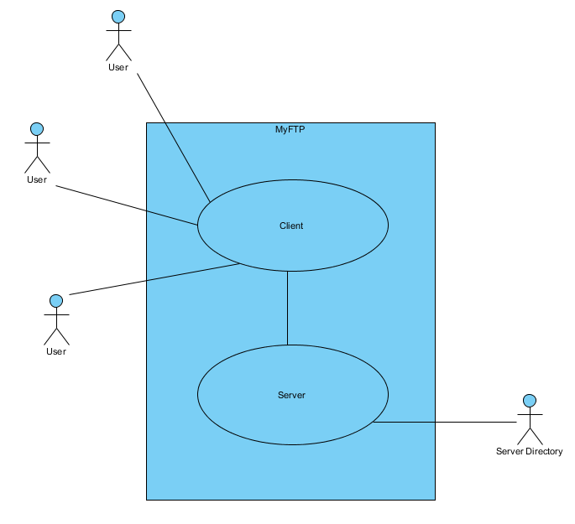

System Environment

MyFTP can handle multiple Users using Client to connect to Server. Server will store all files in the Server Directory specified in configuration file.

2.2 Operating Environment
The System will work on Windows 7 operating system with minimum of 2 GB RAM and Intel Core2Duo series processor. Both Client and Server will need enough amount of hard drive space of minimum 30 GB.

2.3 Design and Implementation Constraints
Tools: Microsoft Visual Studio 2013 Community Edition
GitHub
Language: C++, standard version: ISO/IEC 14882:2003
Other: syntax compatible with the Google C++ Style Guide
Creating log files in development phase?

2.4 Functional Requirements Specification

2.4.1 User Use Cases
The User has the following set of use cases:

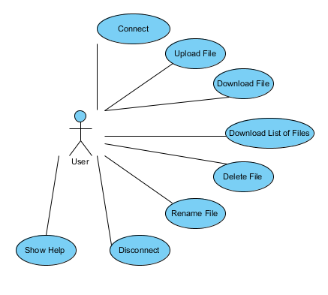

Use case: Connect

Brief Description
The User connects to server.

Initial Step-By-Step Description
This use case requires that server is working.

- The User type connect command.
- The System establish connection between Client and Server.
- The System display proper message.

Use case: Upload File

Brief Description
The User either upload a new file or reupload an edited file.

Initial Step-By-Step Description
Before this use case can be initiated, the User must be already connected to Server.
- The User type upload command along with file name/path.
- The System uses TCP to send copy of a file to server root directory.
- The System displays progress bar.
- After completed uploading the System display proper message.

Use case: Download File

Brief Description
The User download a file from server directory.

Initial Step-By-Step Description
Before this use case can be initiated, the User must be already connected to Server.

- The User type download command along with file name and destination path for downloaded file.
- The System uses TCP to download copy of a file from Server directory to directory specified by the User.
- The System displays progress bar.
- After completed downloading System display proper message.

Use case: Download List of Files

Brief Description
The User download list of file stored in specified in configuration file Server root directory.

Initial Step-By-Step Description
Before this use case can be initiated, the User must be already connected to Server.

- The User type list command.
- The System go through Server directory and remember all file names.
- The System displays a list contains all remembered names.

Use case: Delete File

Brief Description
The User delete a file from server directory.

Initial Step-By-Step Description
Before this use case can be initiated, the User must be already connected to Server.

- The User type delete command along with file name.
- The System removes indicated file from server directory.
- The System display proper message.

Use case: Rename File

Brief Description
The User rename a file from server directory.

Initial Step-By-Step Description
Before this use case can be initiated, the User must be already connected to Server.

- The User type rename command along with file name and new file name.
- The System rename indicated file from server directory.
- The System display proper message.

Use case: Disconnect

Brief Description
The User disconnects from server.

Initial Step-By-Step Description
Before this use case can be initiated, the User must be already connected to Server.

- The User type disconnect command.
- The System drop connection between Client and Server.
- The System free resources used during connection time.
- The System display proper message.

Use case: Show Help

Brief Description
The User displays list of available commands with brief description next to each one of it.

Initial Step-By-Step Description

- The User type help command.
- The System displays list of all commands in the System with brief description next to each one of it.

2.5 User Characteristics
The User is expected to be console literate and be able to use commands.

3.0. Requirements Specification

3.1 External Interface Requirements
All action will be determinate in Windows terminal window. Client will not have direct access to server directory folder. Only server perform operations in that folder. All file transport operations will use TCP protocol. MyFTP will use processes and threats to provide multi-user, multi-tasking environment.

3.2 Functional Requirements

3.2.1 Connect

Use Case Name | Connect
Trigger | The User type connect command.
Precondition | The Server is working.
Basic Path | - The System establish connection with Server.  - The System display proper message to the User.
Alternative Paths | In step 1, if the Server is not working or IP given in configuration file is incorrect.  - The System display message about connection failure.
Postcondition | The User is connected with Server.
Other | The User connect to Server using IP held in configuration file.

3.2.2 Upload File

Use Case Name | Upload File
Trigger | The User type upload command along with file name/path.
Precondition | The User is connected with Server.
Basic Path | - The System checks if file that User want to send exists.  - The System checks if file of given name exists in server directory.  - The System upload file from client directory to server directory using TCP protocol.  - The System display information about progress of uploading.  - After completed System display proper message.
Alternative Paths | In step 1, if file does not exist uploading file is abandon and the User get a proper message from the System.  In step 2, if file exists in server directory.  - The System display message about file already exists in server directory.  - The System ask the User if he want to upload and replace existing file anyway.  - The User can either continue uploading or abandon operation.  - If the User continue uploading anyway, System check if file is being used by other users.  - If the file is being used by another users the System display message if the User want to wait and upload the file or abandon operation.  - If the User want to continue the System block uploading to the point where all users stops use the file.
Postcondition | Copy of uploading file is in the server directory.
Other | None

3.2.3 Download File

Use Case Name | Download File
Trigger | The User type download command along with file name.
Precondition | The User is connected with Server.
Basic Path | - The System checks if file of given name exists in server directory.  - The System download file from server directory to client directory using TCP protocol.  - The System display information about progress of downloading.  - After completed System display proper message.
Alternative Paths | In step 1, if file of given name does not exist downloading file is abandon and the User get a proper message from the System.
Postcondition | Copy of downloading file is in the client directory.
Other | None.

3.2.4 Download List of Files

Use Case Name | Download List of Files
Trigger | The User type list command.
Precondition | The User is connected with Server.
Basic Path | - The System go through server directory and remember files names.  - The System display files names one by one in a list.
Alternative Paths | In step 1, if there is no file in server directory System display a proper message.
Postcondition | The User gets all the file names in server directory.
Other | None.

3.2.5 Delete File

Use Case Name | Delete File
Trigger | The User type delete command along with file name.
Precondition | The User is connected with Server.
Basic Path | - The System checks if file of given name exists in server directory.  - The System checks if file being used by other users.  - The System deletes file from server directory.  - The System display proper message.
Alternative Paths | In step 1, if file of given name does not exist deleting file is abandon and the User get a proper message from the System.  In step 2, if file is being used by other users  - The System block deleting operation.  - The System display message if the User want to wait and delete the file or abandon operation.  - The System either block deleting to the point where all users stops use the file or abandon it and display proper message.
Postcondition | The file is remove from server directory.
Other | None.

3.2.6 Rename File

Use Case Name | Rename File
Trigger | The User type rename command along with file name and new file name.
Precondition | The User is connected with Server.
Basic Path | - The System checks if file of given name exists in server directory.  - The System checks if file being used by other users.  - The System rename file from server directory to new file name given by the User.  - The System display proper message.
Alternative Paths | In step 1, if file of given name does not exist renaming file is abandon and the User get a proper message from the System.  In step 2, if file is being used by other users  - The System block renaming operation.  - The System display message if the User want to wait and rename the file or abandon operation.  - The System either block renaming to the point where all users stops use the file or abandon it and display proper message.
Postcondition | The file from server directory is renamed.
Other | New file name must be in accordance with the rules of file name nomenclature. (specified in link in 1.4 References)

3.2.7 Disconnect

Use Case Name | Disconnect
Trigger | The User type disconnect command.
Precondition | The User is connected with Server.
Basic Path | - The System drop connection with Server.  - The System free resources allocated before by Server for this specific Client.  - The System display proper message to the User.
Alternative Paths | None
Postcondition | The User is disconnected to Server.
Other | None.

3.2.8 Show Help

Use Case Name | Show Help
Trigger | The User type help command.
Precondition | None.
Basic Path | The System displays list of available commands with brief description next to one of each.
Alternative Paths | None
Postcondition | The User is shown commands with explanation how and what for use it.
Other | None.

3.3 Non-Functional Requirements

3.3.1 Performance

The delay for the System returning message must be under 2 sec unless it is operation that require download, or upload file. In that case operation must end in non-specified time.

3.3.2 Reliability

All files downloading from, or uploading on server directory must be the same in both client and server directory. All users mu see exactly the same file list stored in server directory.

3.3.3 Security

The System will not be connected to internet, or stored any confidential information so there is no special security requirements.

3.3.2 Usability

The System is easy to maintain and the User got all command listed, and explained after type help command.

